**DAILY ONLINE ACTIVITIES SUMMARY**

|  |  |  |  |  |  |  |  |
| --- | --- | --- | --- | --- | --- | --- | --- |
| **Date:** | **30/05/2020** | | | | **Name:** | **Namratha C** | |
| **Sem & Sec** | **8th sem, A sec** | | | | **USN:** | **4AL16CS056** | |
| **Online Test Summary** | | | | | | | |
| **Subject** | | **No Test Conducted** | | | | | |
| **Max. Marks** | |  | | **Score** | |  | |
| **Certification Course Summary** | | | | | | | |
| **Course** | **Introduction to Amazon CloudFront** | | | | | | |
| **Certificate Provider** | | | **Aws training and certification** | **Duration** | | | **10 mins** |
| **Coding Challenges** | | | | | | | |
| **Problem Statement: 1)** program to print YES if the string contains equal number of a's ans b's else print NO. | | | | | | | |
| **Status: Completed** | | | | | | | |
| **Uploaded the report in Github** | | | | **Yes** | | | |
| **If yes Repository name** | | | | **CODES (Namrathasonu)** | | | |
| **Uploaded the report in slack** | | | | **Yes** | | | |

Online Test Details: **No test conducted**

Certification Course Details:

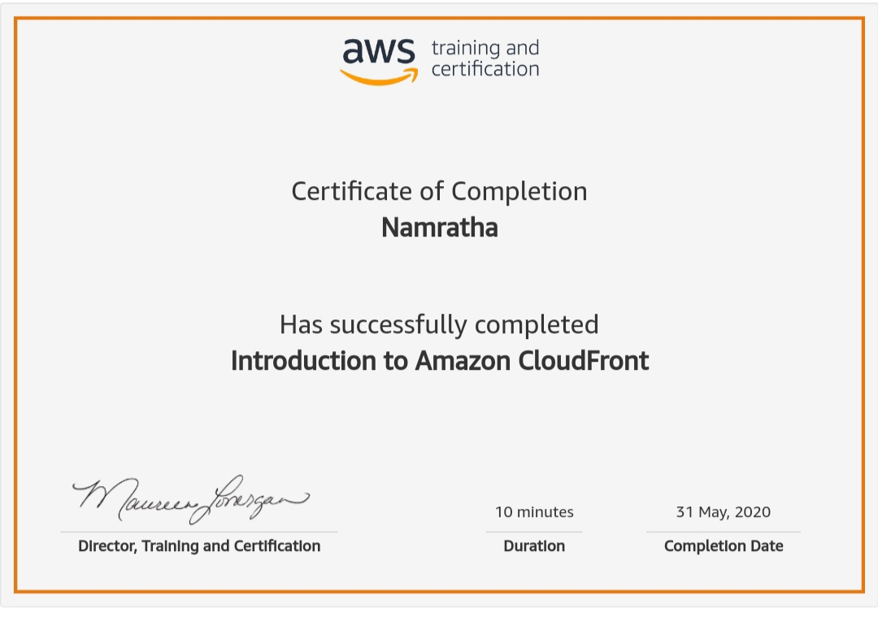

Amazon CloudFront is a web service that speeds up distribution of your static and dynamic web content, such as .html, .css, .js, and image files, to your users. CloudFront delivers your content through a worldwide network of data centers called edge locations. When a user requests content that you're serving with CloudFront, the user is routed to the edge location that provides the lowest latency (time delay), so that content is delivered with the best possible performance.

Coding Challenges Details:

1)

#input 1 : a, b, ab, aabb, aaabbb

#output 1: YES

#input2: aab, abb, aaabb, aabbb

#output2: NO.

n = input('Enter a string \n')

l = list(n)

a = []

w = []

for i in range(len(l)):

if l[i] not in a:

a.append(l[i])

w.append(l.count(l[i]))

if len(set(w)) == 1:

print("YES")

else:

print("NO")